**06: Create EKS Cluster**

--- **Reference** - https://github.com/stacksimplify/aws-eks-kubernetes-masterclass

--- **Repository documentation path** - [aws-eks-kubernetes-masterclass](https://github.com/stacksimplify/aws-eks-kubernetes-masterclass)/[01-EKS-Create-Cluster-using-eksctl](https://github.com/stacksimplify/aws-eks-kubernetes-masterclass/tree/master/01-EKS-Create-Cluster-using-eksctl)/**01-02-Create-EKSCluster-and-NodeGroups**/

**Create EKS Cluster using eksctl**

--- It will take 15 to 20 minutes to create the Cluster Control Plane

**# Create Cluster**

--- **eksctl create cluster --name=eksdemo1 \**

**--region=us-east-1 \**

**--zones=us-east-1a,us-east-1b \**

**--without-nodegroup**

**# Get List of clusters**

--- **eksctl get cluster**

--- **--without-nodegroup** – if you don’t give this while creating cluster using **eksctl** then it will create production grade cluster.

--- -name=eksdemo1 – it is the cluster name.

**Cluster kube config fille**

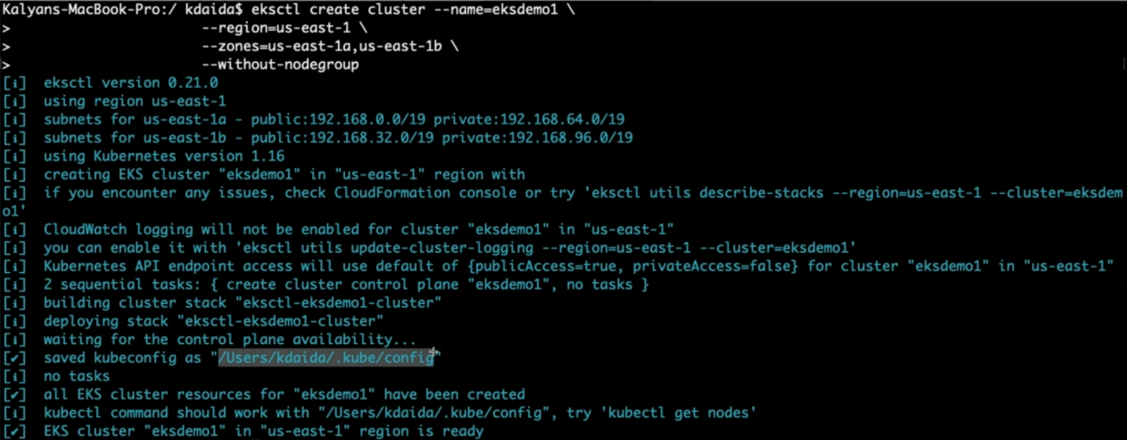

--- **/users/kdaida/.kube/config** – it saved cluster config file under this directory.

--- **eksctl get cluster** – list the clusters we created.